***Developer Guide***

*EPROJECT*

*ONLINE STATIONARY MANAGEMENT SYSTEM*

|  |  |  |
| --- | --- | --- |
| **Supervisor.** | **Miss Warda Jawed** | |
| **Batch.** | **2302E2** | |
| **Group.** | A | |
| **Semester** | **HDSE 1** | |
| **Serial No.** | **Enrollment Number** | **Student Name** |
| 1. | 1458683 | Qurat Ul Ain |
| 2. | 1458664 | Muneeb Ur Rehman |
| 3. | 1458357 | Muhammad Taha Shahid |
| 4. | 1457819 | Sundus Khalid |
| 5. | 1445155 | Umme Fatima |

*INTRODUCTION & SNAPSHOTS:*

*Access Panel:*

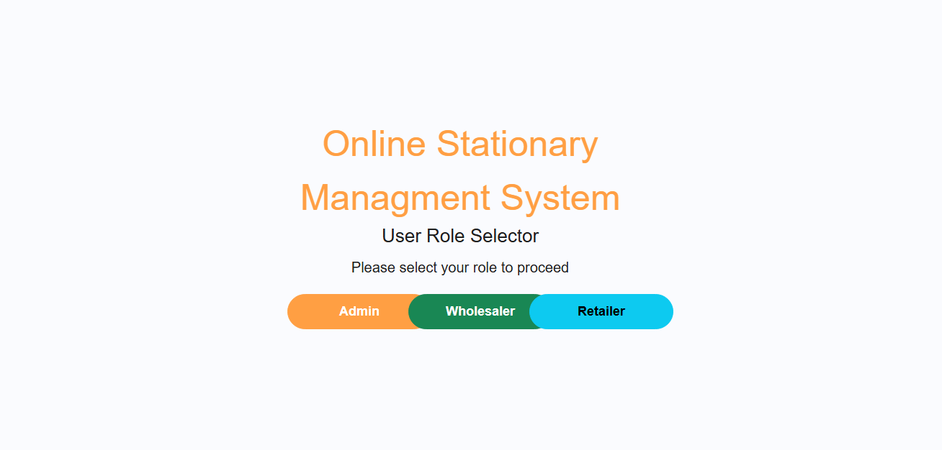

*Figure: 1 Access panel of our website*

This is the access panel of our website which has three buttons which you can click to go to the direct page.

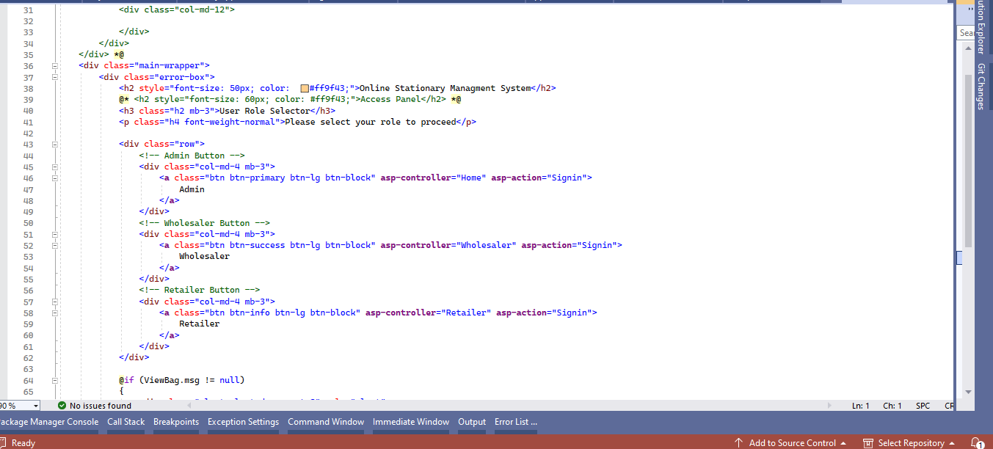 **Code of Access panel:**

*Admin Sign-In:*

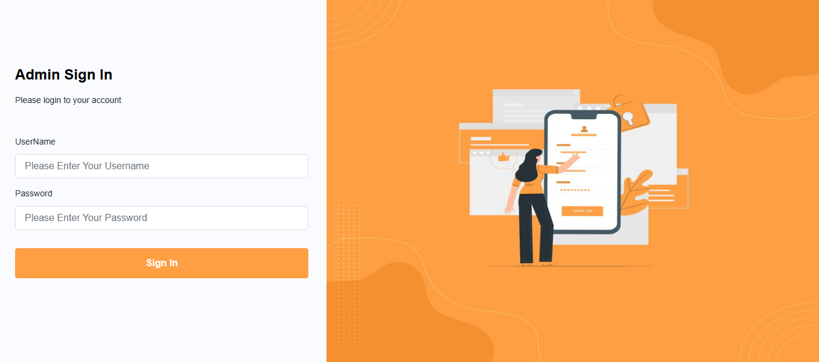

*Figure: 2 Admin Sign in page*

This is our admin sign-in page, which you can fill out to access the admin page.

**Code of Admin sign in page:**

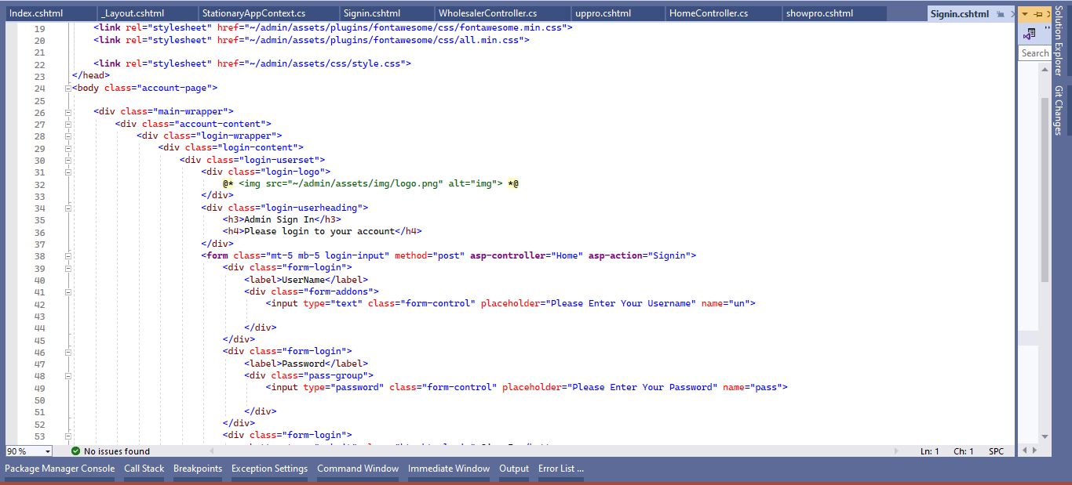

*Wholesaler Sign-In:*

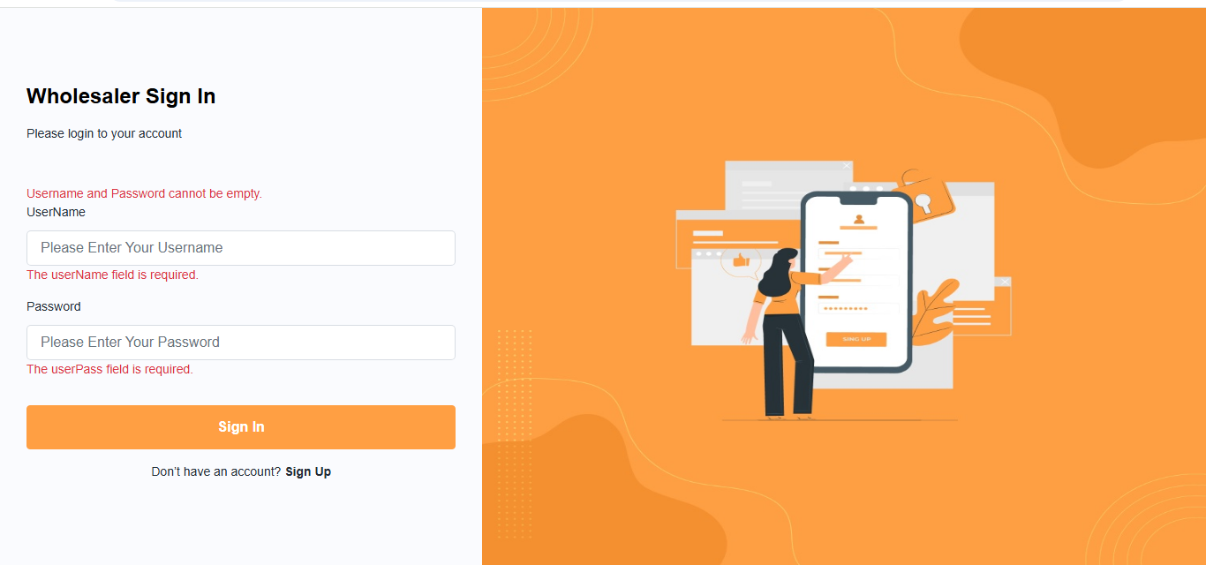

*Figure: 3 Wholesaler Sign in page*

This is our Wholesaler sign-in page, which you can fill out to access the Wholesaler page.

**Code of Wholesaler Sign****In page:**

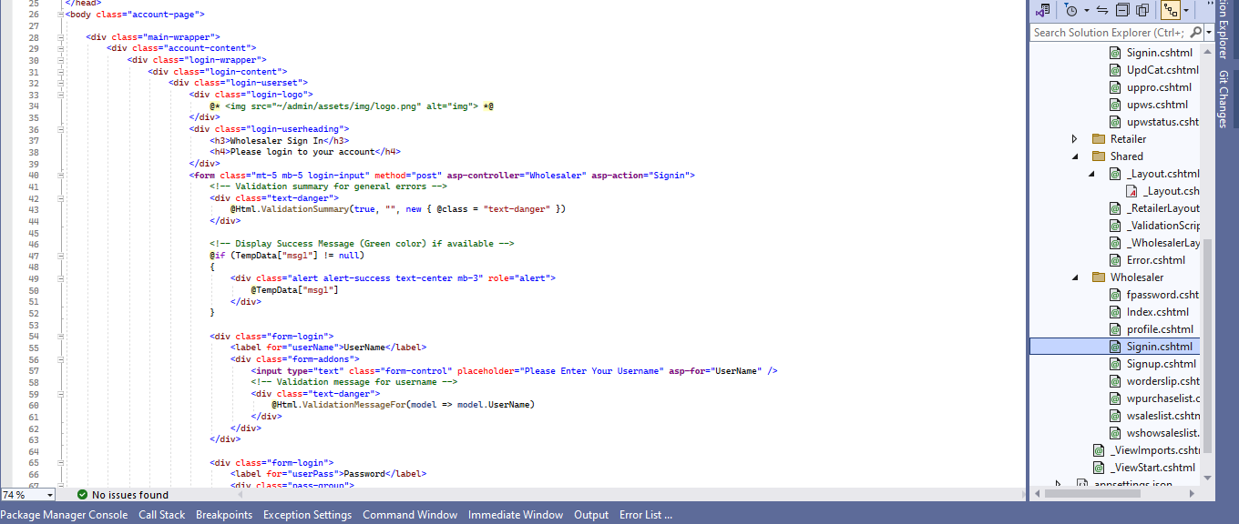

*Retailer Sign-In:*

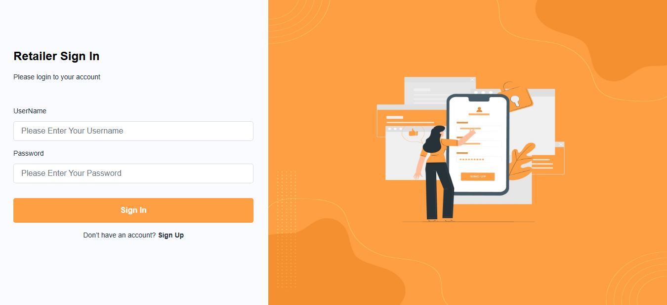

*Figure: 4 Retailer Sign in page*

This is our Retailer sign-in page, which you can fill out to access the Retailer page.

**Code of Retailer sign in page:**

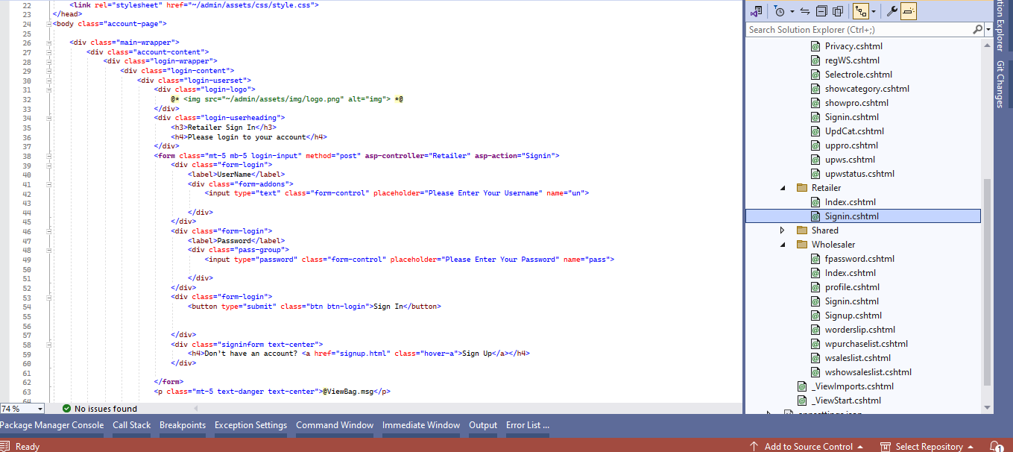

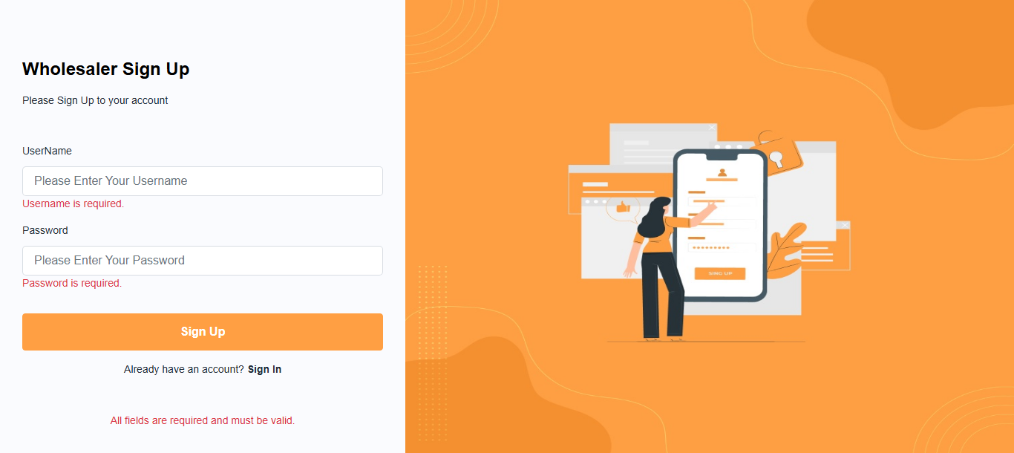*Wholesaler Sign-Up:*

*Figure: 5 Wholesaler Sign up page*

This is our wholesaler sign-up page, where you will first sign up and then sign in.

**Code of Wholesaler sign up page:**

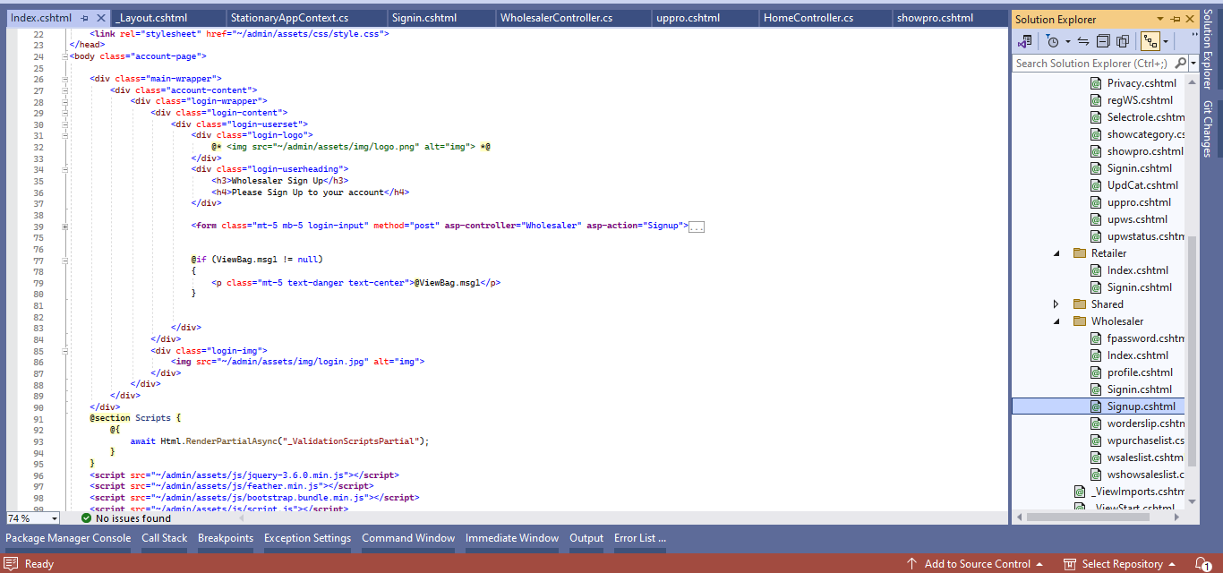

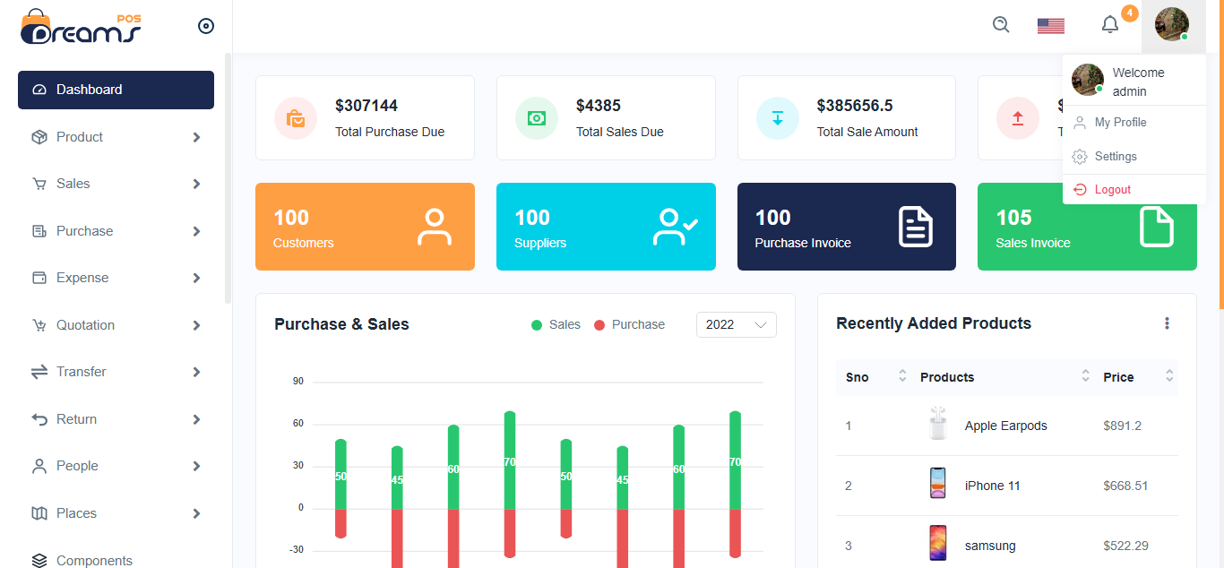*Dashboard (Admin):*

*Figure: 5 Wholesaler Sign up page*

*Figure: 6 Dashboard Admin page*

This is our admin dashboard page, where you will access all pages.

**Code of Dashboard Admin page:**

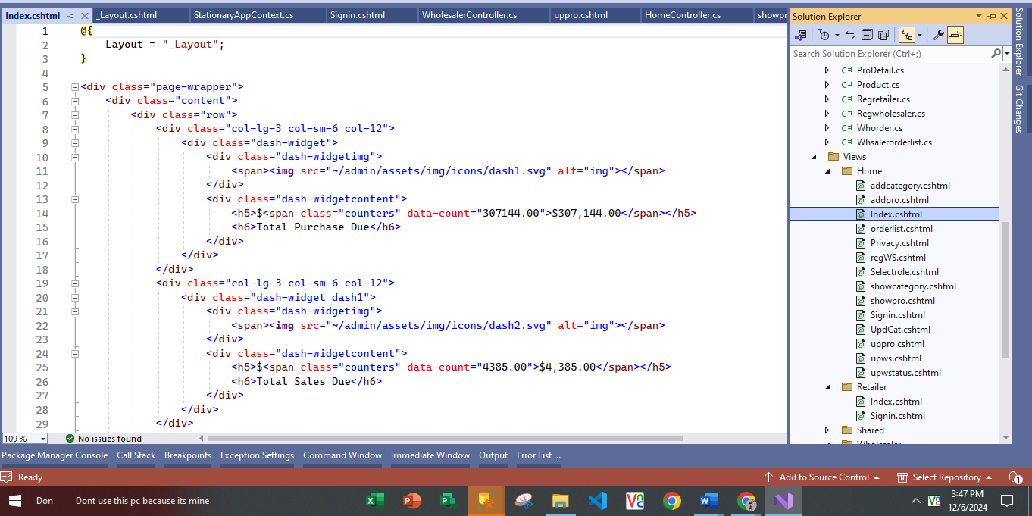

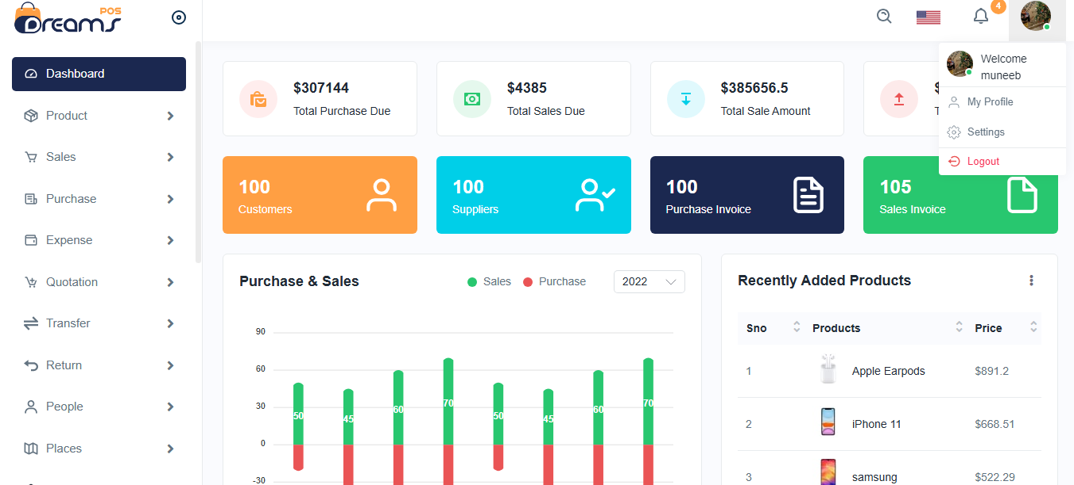*Dashboard (Wholesaler):*

*Figure: 7 Dashboard Wholesaler page*

This is our dashboard wholesaler page, where you will access all pages.

**Code of Dashboard Wholesaler page:**

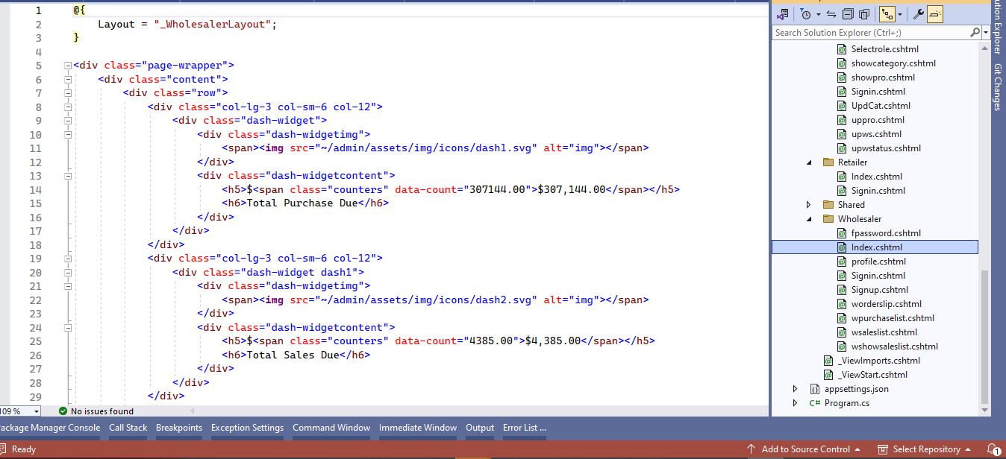

*product List:*

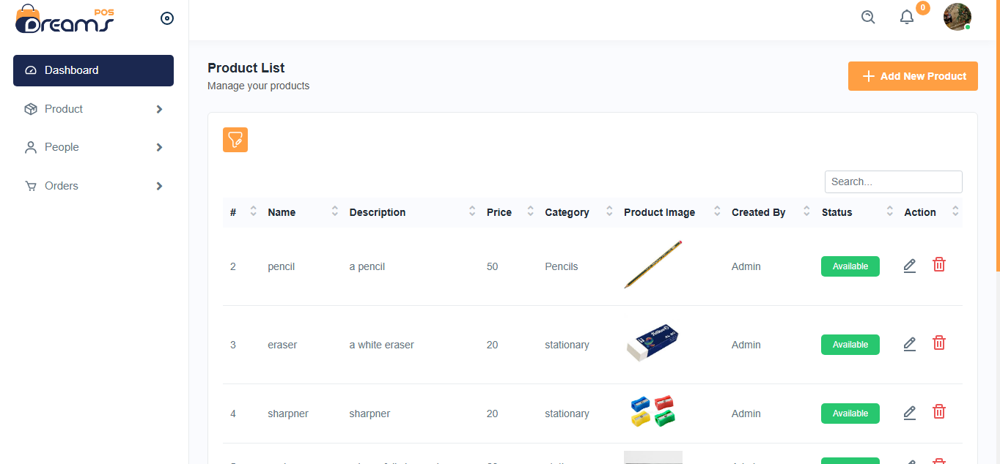

*Figure: 8 Product List page*

This is our product list page, where the products ordered by the user will be displayed, along with details such as the product's ID, name, description, price, and image.

**Code of Product List page:**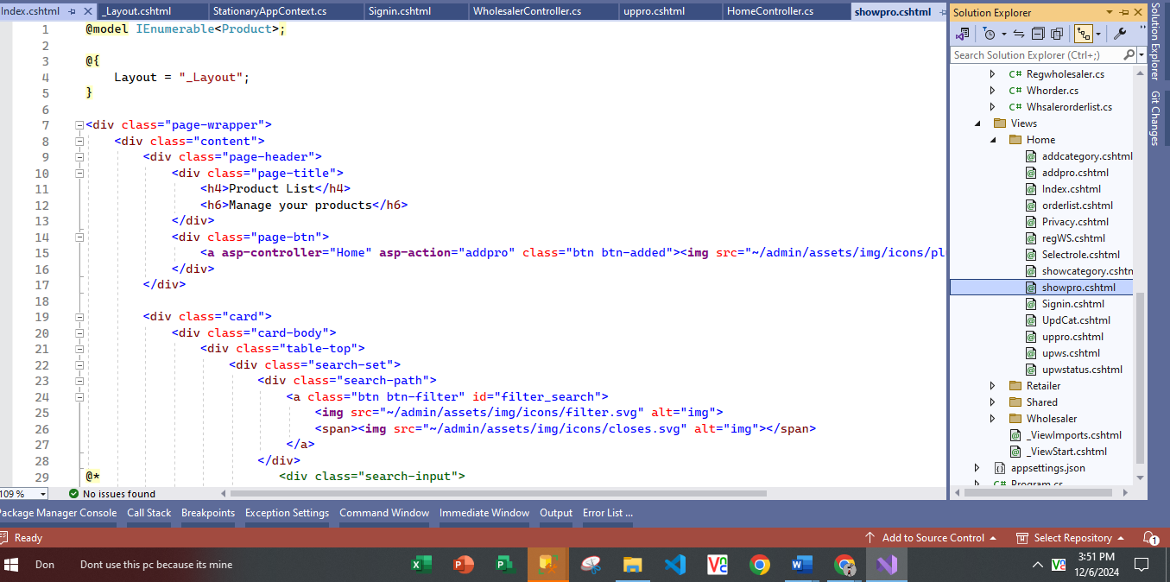

*Category List:*

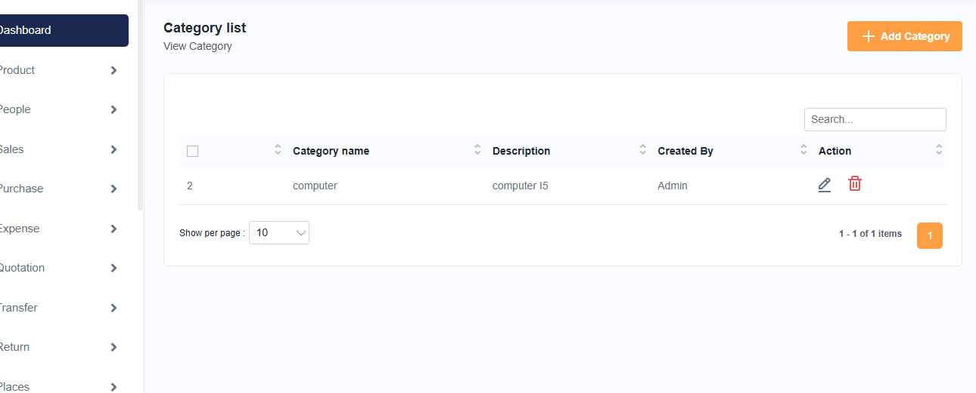

*Figure: 9 Category List page*

This is our category list page, where the products ordered by the user will be displayed, along with details such as the Category name, description and who is created.

**Code of Category List page:**

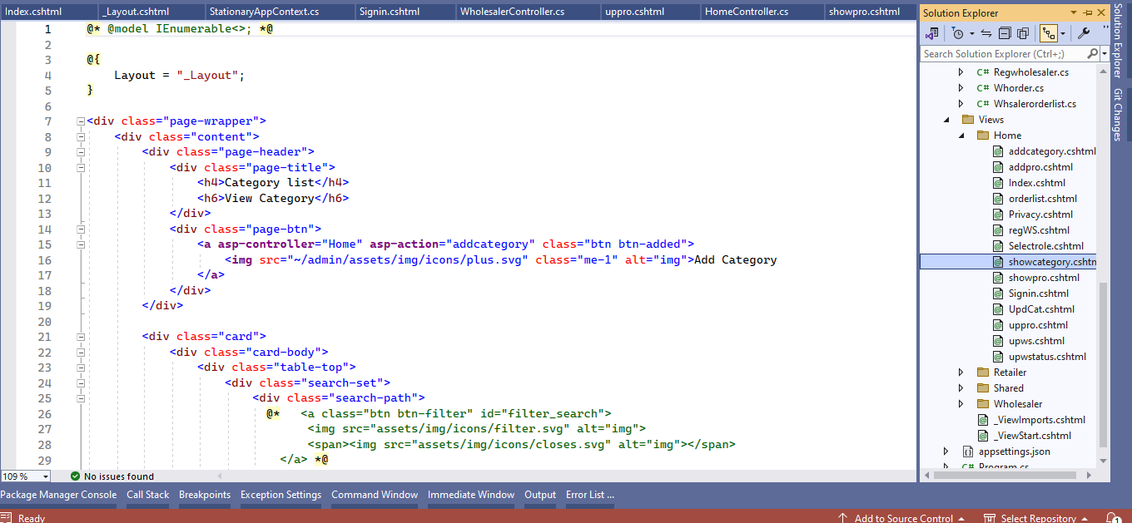

*Add Category:* 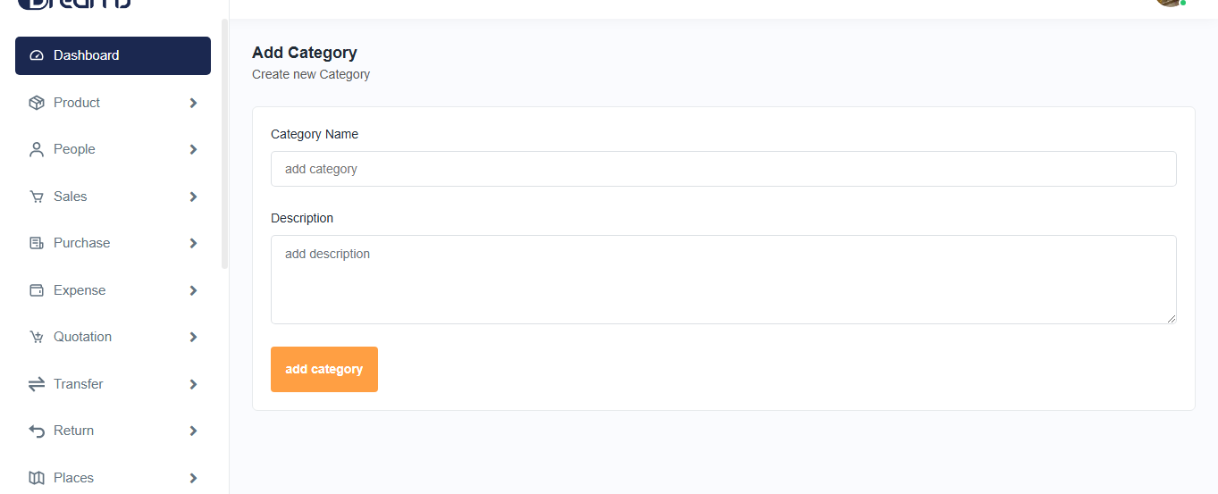

*Figure: 10 Add Category page*

This is our add category page, where we add product categories by entering the category name and category description.

**Code of Add Category page:**

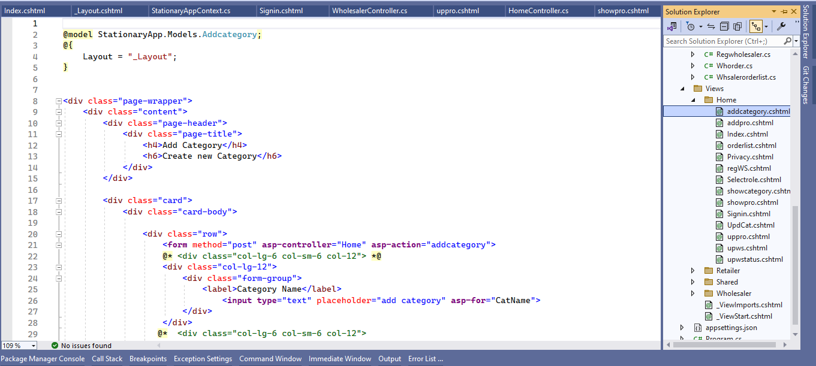

*Product Add:* 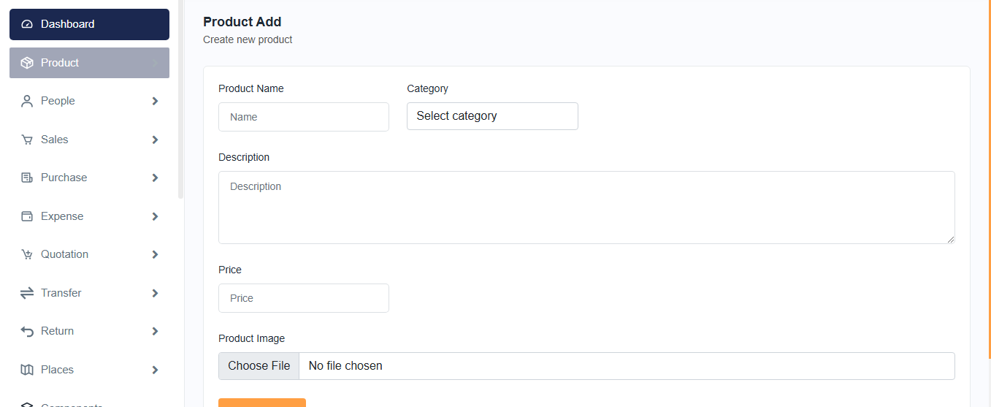

*Figure: 11 Product Add page*

This is our product add page, where we add product by entering the product name, category name, description, price or product image.

**Code of Product Add page:**

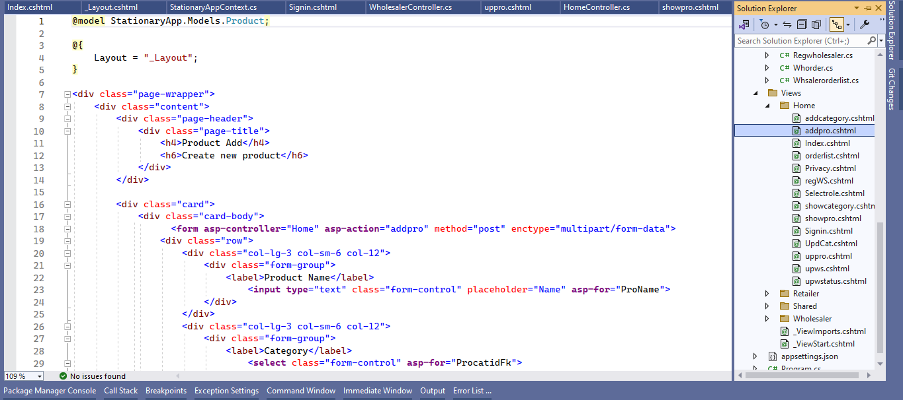

*Edit Product:* 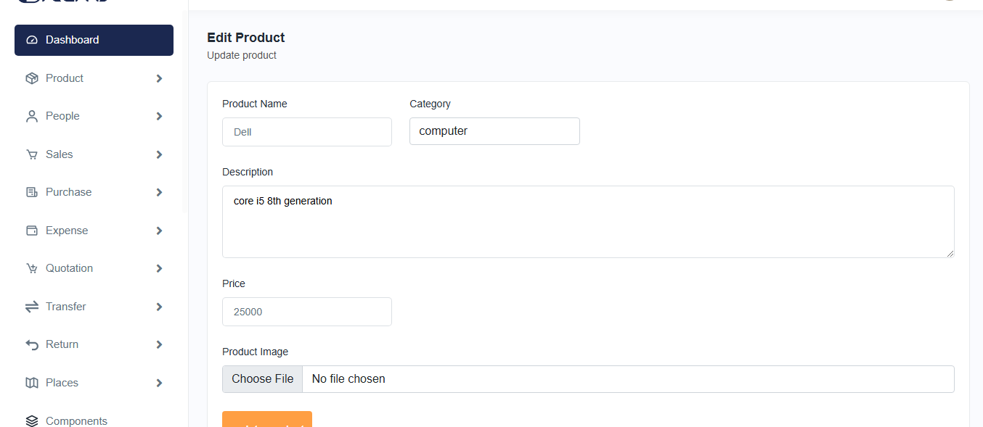

*Figure: 12 Edit Product page*

This is our edit product page we can edit product from category list by entering the product name, category name, description, price or product image.

**Code of Edit Product page:**

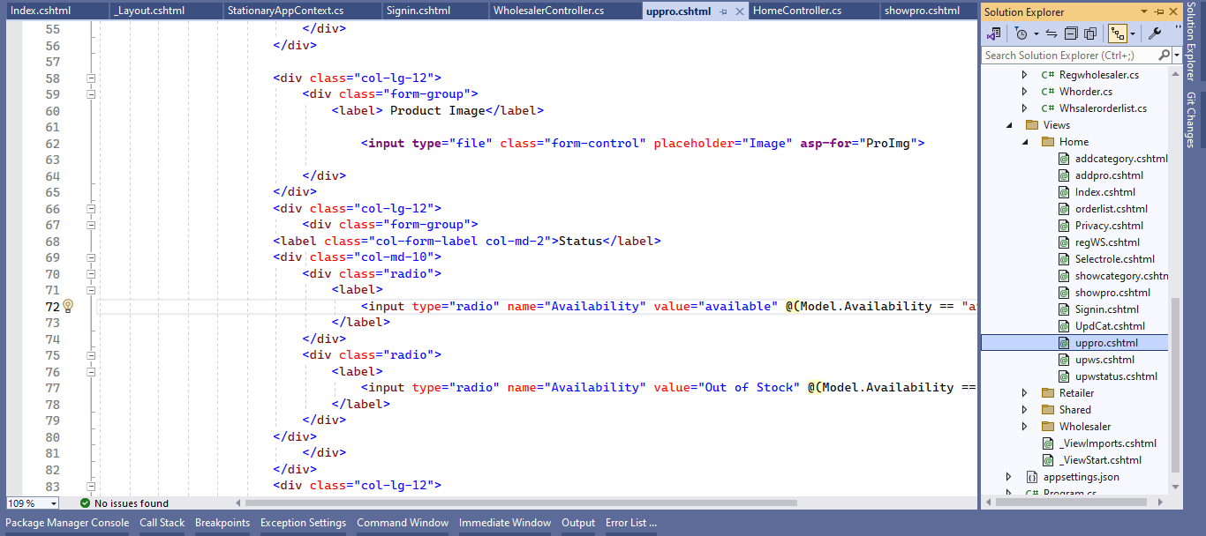

*Edit Category:*

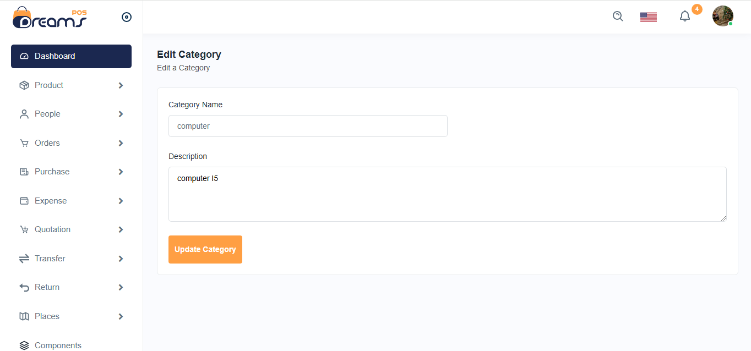

*Figure: 13 Edit Category page*

This is our edit category page, where we can edit category from category list by entering the category name, description.

In this page category details can be updated.

**Code of Edit Category page:**

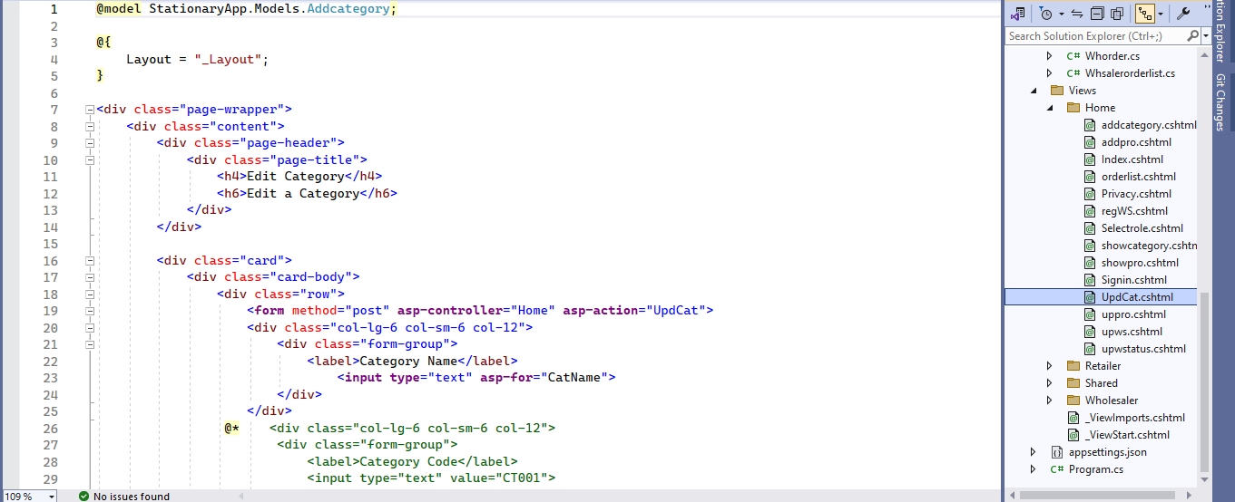

*Wholesaler List:*

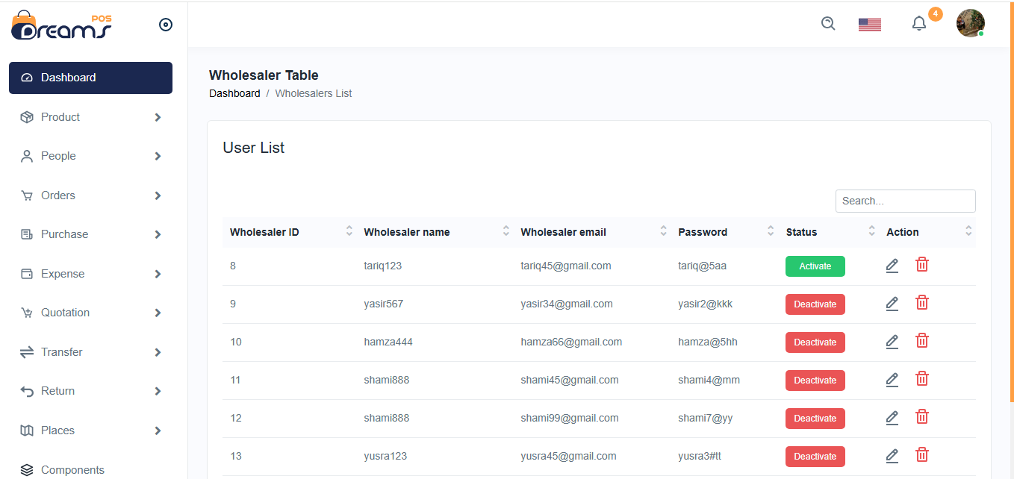

*Figure: 14 Wholesaler list page*

This is our wholesaler page, which includes ID, name, password, email, password, and status. In this page, we can activate , deactivate edit or delete products.

**Code of Wholesaler list page:**

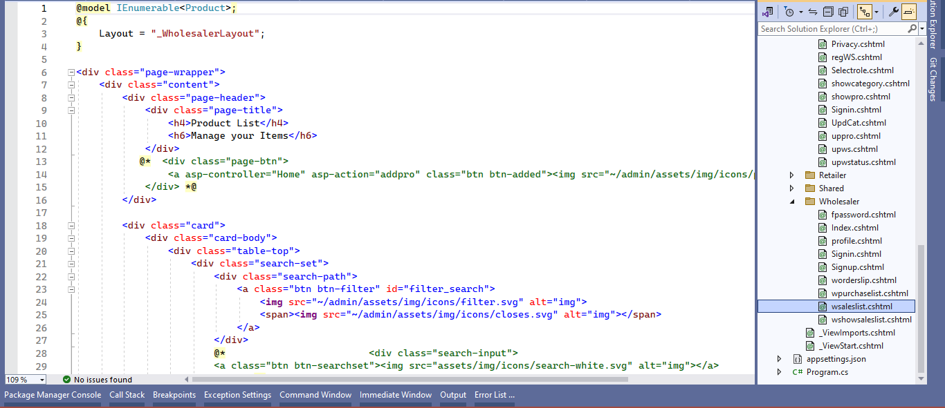

*Wholesaler Product List:*



*Figure: 15 Wholesaler Product list page*

This is our wholesaler product list page, which includes Product ID, name, description price, category, image and action to show the product details.

**Code of Wholesaler Product list page:**

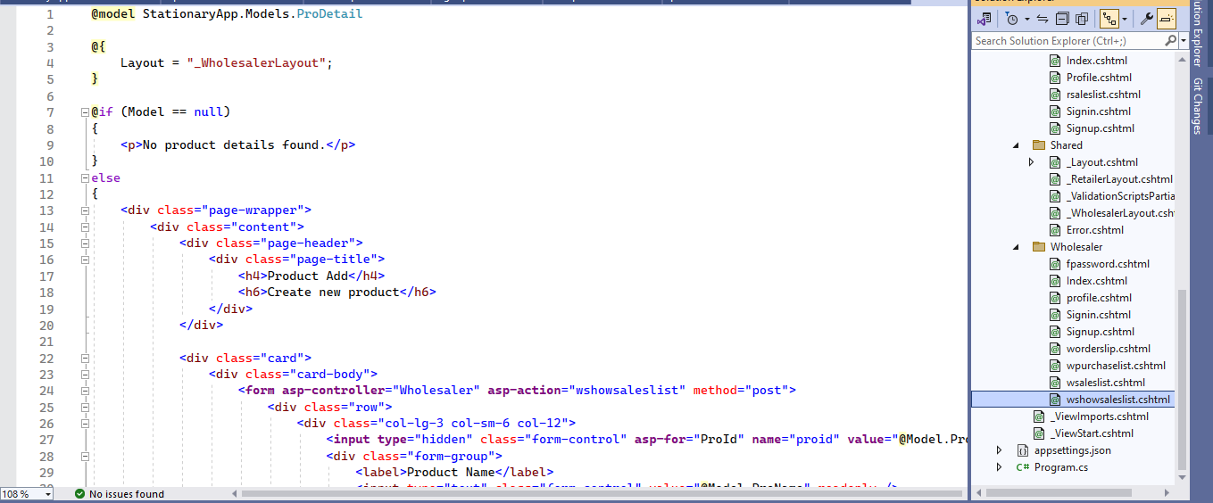

*Wholesaler Purchase List:*

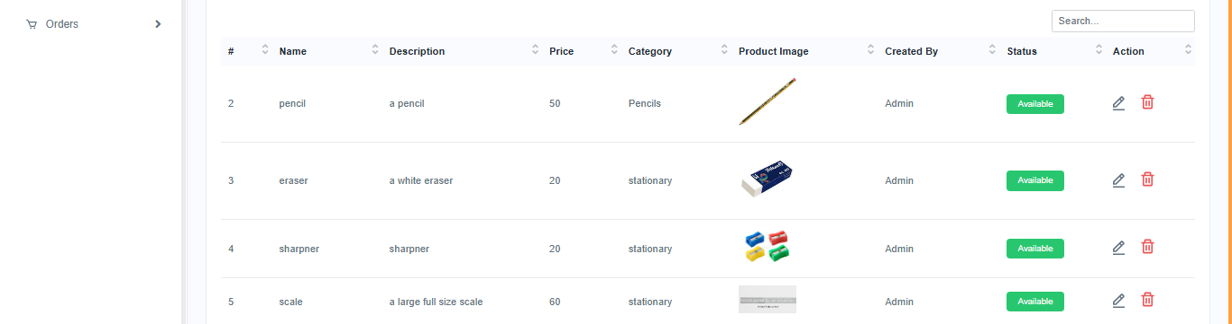

*Figure: 16 Wholesaler Purchase list page*

This is our wholesaler purchase list page, which includes Product name, category name description price, quantity, total price image, status and action to show the purchase details.

**Code of Wholesaler purchase list page:**

